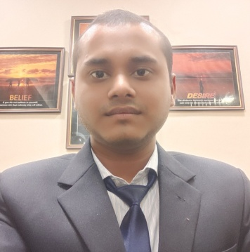

SHASHIKANT BHARGAV

Contact: +91-8303089818

E-Mail: bhargavshashi8953@gmail.com

**CAREER OBJECTIVE**

• My goal will be the goal of the company.

 • I am seeking a IT company where I can use my skills.

 • My growth with contribute the growth of the company.

**PROJECT**

• **Project Title : E-CHARITY** Duration:- 5 month

Team size- 3

   Front End : HTML, CSS, BOOTSTRAP, JAVASCRIPTS.

  Back End : Django with sqlite database.

  Contribute : coding and database.

  Description : This project(e-CHARITY) is designed for online charity. Using of this project any person

can donate to any person from anywhere without meeting to each other. The main purpose of this

project is provide food, cloth and other material to poor peoples.

• **Project Title : FOOD ORDERING SYSTEM**  Duration:- 4 month

   Front End : HTML, CSS, BOOTSTRAP.

  Back End : Django with sqlite database.

  Contribute : Design, coding and database.

Description : This project(Food Ordering System) is designed for online food ordering. The purpose

of this project is to provide food to your door . many people do not like to go out to eat food, this is

the best for them.

• **Project Title : FACULTY FEEDBACK SYSTEM** Duration:- 5 month

Team size : 4

  Front End : ASP.NET(C#)

  Back End : MS-ACCESS.

  Contribute : coding and database.

  Description : This project(Faculty Feedback System) is designed for online faculty feedback. By the

using of this project students give the feedback to the faculty. The advantage of this project college

and school can save the feedback for a long time.

**LANGUAGE CERTIFICATION**

• Certificate in “Python programming language”.

• Certificate in “Web designing”

• Certificate in “Python programing to masterclass”.

• Certificate in “Django full stack developer”.

**SEMINAR/WEBINAR**

• I attended a Cloud Computing seminar in 2017.

• I attended C programing seminar in 2018.

 • I attended Python programing seminar in 2018.

• I attended a Softskill seminar in 2019.

**IT SKILLS**

• HTML, CSS, Bootstrap, python

• MySQL, Sqlite

• MS-Office, MS-word.

• Python with django framework

• Github (user_name : ShashikantBhargav)

**EDUCATION**

M.C.A from Jagran Institute of Management.

B.C.A from CSJM University.

Intermediate from Shivaji Inter College.

High School from Shivaji Inter College.

**STRENGTH**

 Hardworking

Punctual

**DECLARATION**

I hereby declared that the above mentioned information is correct up to my knowledge and I bear the  responsibility for the correctness of the above mentioned particulars.